Observation 1:

In the northern hemisphere there is a strong negative correlation between latitude and Max temperature. The correlation between Latitude and the max temp is: -0.8422670163218285.

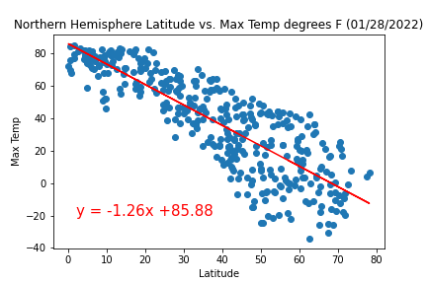

Observation 2:

In the Southern and Northern Hemisphere there is a weak correlation between cloudiness and Latitude. The Correlation coefficient between Latitude and cloudiness for the southern hemisphere is : 0.38095210054547046. 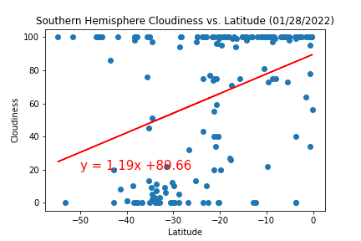

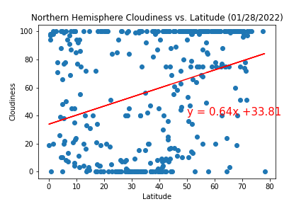

The correlation coefficient for cloudiness and latitude in the Northern Hemisphere is 0.3126325701231053.

**Observation 3-**

The is a very weak correlation between humidity and latitude in the Southern hemisphere. The The correlation between Latitude and humidity is: 0.219119334983756.

